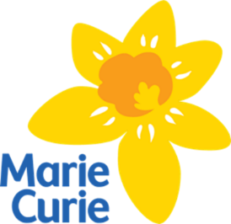

Community Pharmacy Quality Improvement (“Daffodil”) Standards
for Palliative and End of Life Care

LOCAL CONTACT DETAILS
 | Name | Phone

Patient and/or carer ID

General practitioner

Palliative care specialist

Palliative care pharmacist

Hospital specialist

Community nurse (palliative care)

Community/district nurse team

Medicines information centre

Hospice

